

**CIS 11042 – Practical for Essential of ICT and PC Applications**

Information and communication Technology

Faculty of Technology

South Eastern University of Sri Lanka

Registration Number: SEU/IS/22/ICT/075

Academic year: 22/23

Date: 06.02.2025

Lab Sheet 01

**Title:** Work with Computer System, tools for work & study and Desktop accessories

**Aim:**

* Getting familiar with Computer System/ Windows Operating System environment (GUI).
* Customize and Configure Desktop and Start Screen.
* Use appropriate utility tools to do necessary changes or configuration.

**Task:**

1. **Basic Operations**
   1. Starting up and shutting down the computer (alt + f4):

**Starting Up:** press UPS power button to turn UPS on **->** after making sure UPS Turned on Turn on PC by pressing power button.

**Shutting Down:** In Start menu click **“power”** menu **->** click on **“Shutdown”** **OR** Press “**alt + f4”** in Desktop to bring up **“shutdown windows”** menu after making sure drop-down menu is set on Shutdown press OK

* 1. Restarting a computer:

**Start Menu -> Power menu -> click on “Restart”**

* 1. Computer Basic system information:

Open **“This PC”** **-> “right Click” -> “properties”**

* 1. Desktop View

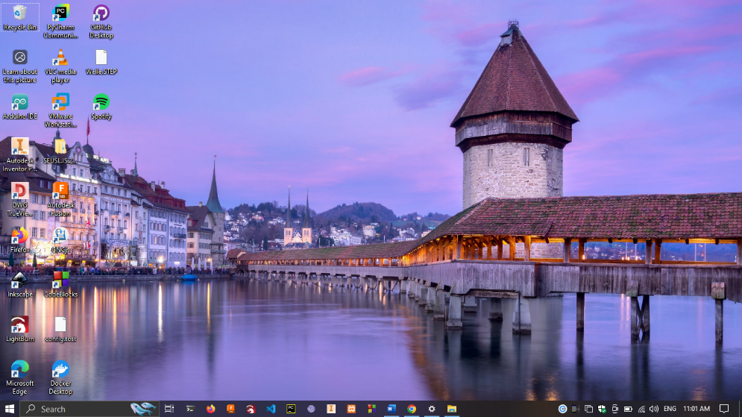

e)

1. Access files in file explorer
2. Right click **“New” -> “Folder”** to create folder
3. Ctrl + C
4. Ctrl + D
5. **Customizing the Start Screen**

a)

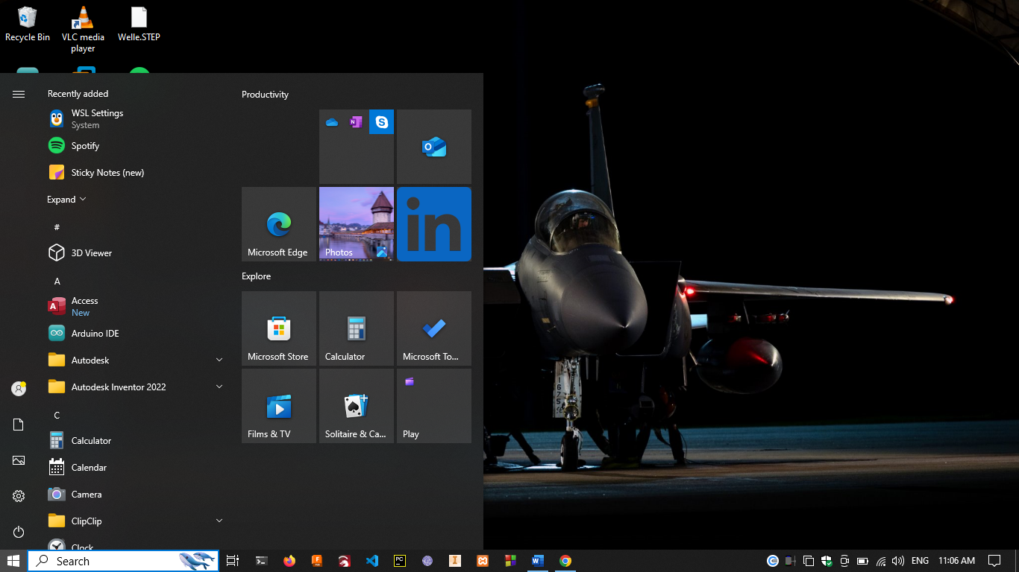

6

5

4

**1**

3

2

1. Recently added applications
2. Application List
3. System Icons
4. Start Button
5. Search Bar
6. Task Bar

b) Pin and Unpin Apps, folders and files to the Start Screen.

**Pin and unpin Apps:**

1. Click on **Start Button** **->** select the application that need to pin in start menu **->** Right Click on the application **->** Click on **Pin on Start**
2. Click on **Start Button ->** Right click on pined application **-> Unpin from Start**

**Pin and Unpin Files and Folders:**

1. Right click on the Folder or File **->**  click **pin on start**

c) Resize Start Screen Tiles.

* Click on Start menu **->**  Right Click on Tiles **->** Under the Resize option selected desire size

1. Personalize the Start Screen.

* Right click on Desktop **->** click on **“Personalize”** **->**  click on **“Start”**

1. **Customizing with the windows Desktop and Task bar**
2. Personalize your desktop
3. Change Desktop icons.

Open **Settings -> Personalization -> Themes -> Desktop icon Settings -> select and click change icon -> select icon and click ok**

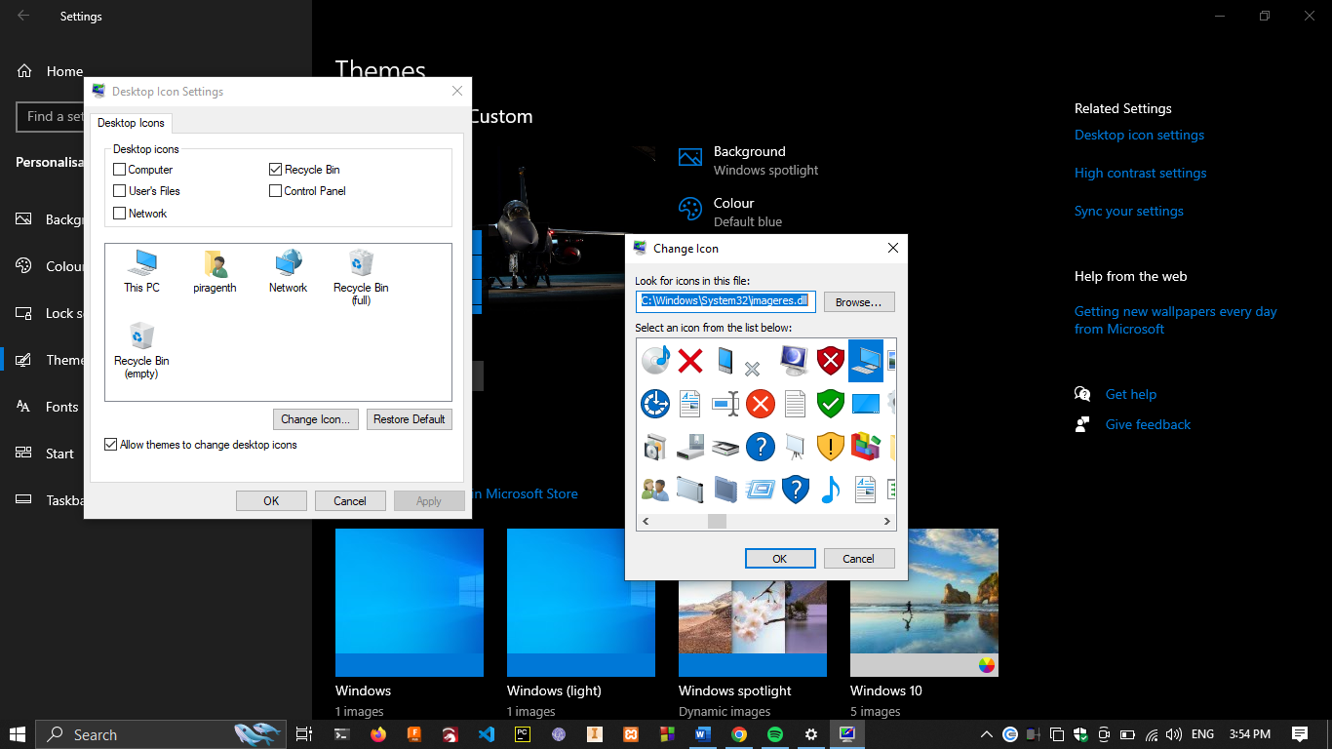

1. Customize Mouse pointer.

**-> Setting -> Personalize -> Themes -> Mouse cursor settings -> select “cursor type” -> ok -> Apply**

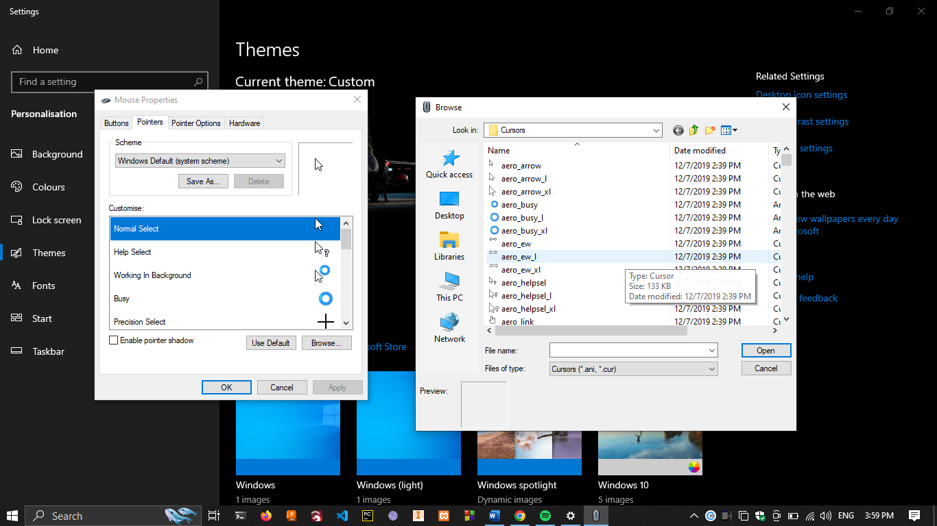

1. Change font size.

In Start menu click **“Settings” -> “Ease of access” -> “Display”** -> use the slider to change the font size

1. Change the background and color

**“Settings” -> “Personalize” -> “Background”** to change background

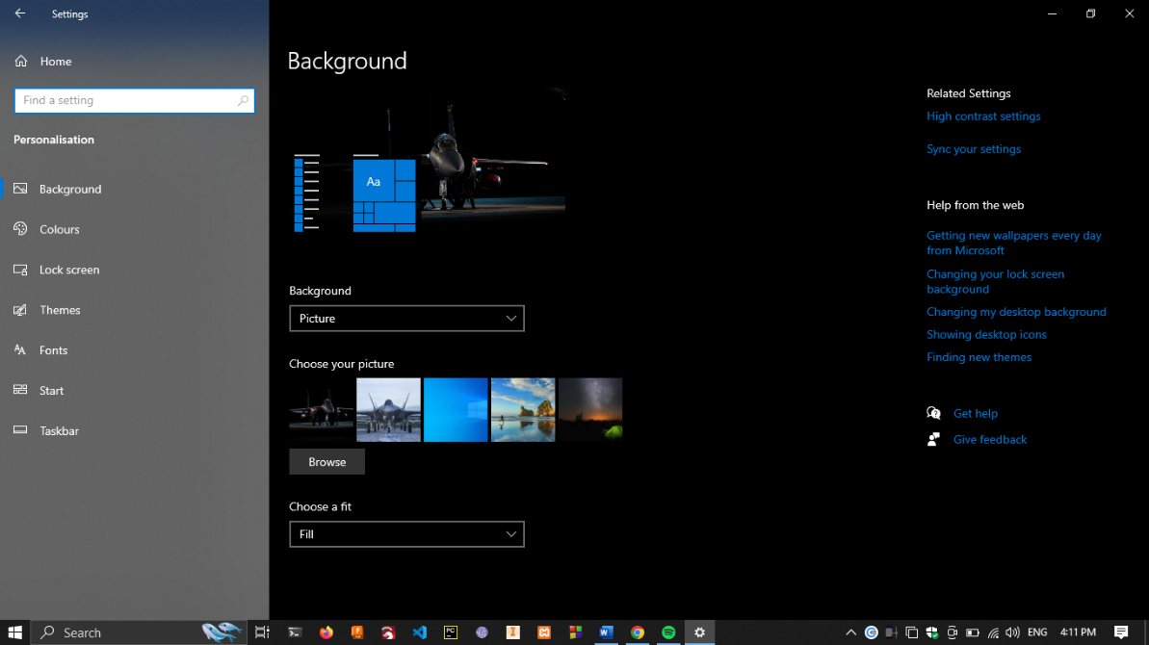

Select the **Colours** tab to change the system color

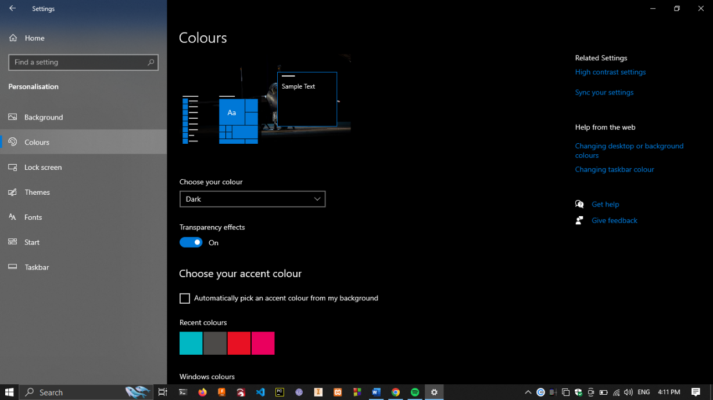

1. Add icons to your desktop

**Start -> Settings -> Personalize -> Themes -> Desktop icon Settings -> Select the icons -> ok -> Apply**

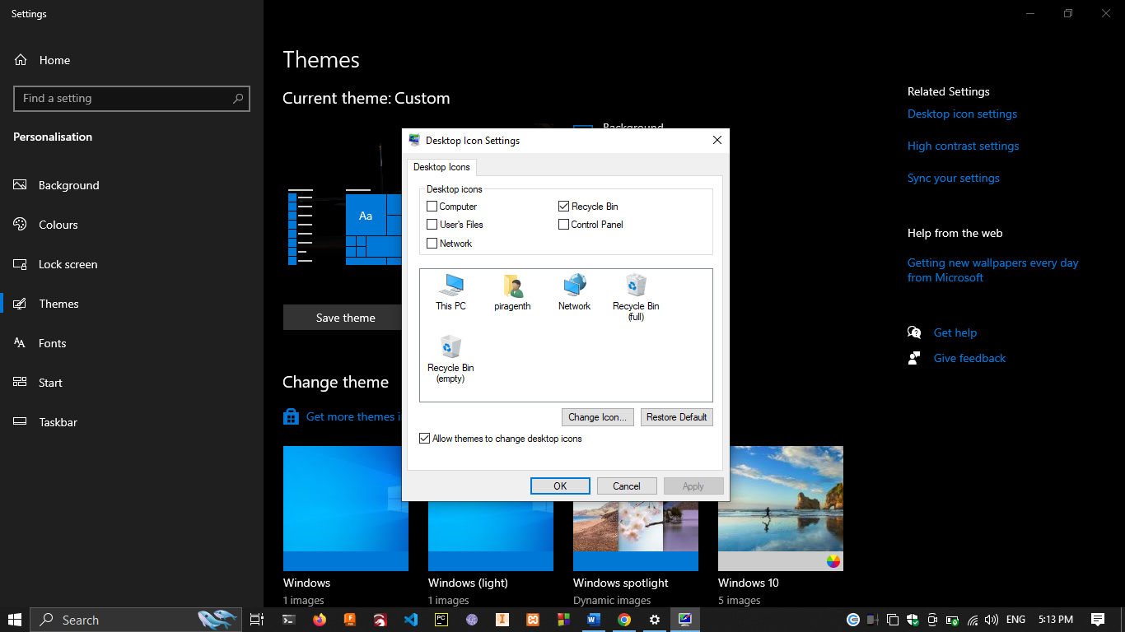

C) Create Folders on your Desktop

Right click on desktop -> under New select **“Folder”** -> naming it as **“SEU/IS/22/ICT/075”**

Open created folder -> creating folder name “Piragenth”

Compress the folder by Right clicking on the folder -> under **send to** -> select compressed (zipped) folder

Right click on Desktop New -> Shortcut -> Browse the item -> Save

Select the file or folder. Right click on the file or folder -> send to -> desktop (create shortcut)

1. Managing user accounts and parental controls.
   1. Create a User Account

Start -> Setting -> Accounts -> Family & Other users -> add someone else to this pc

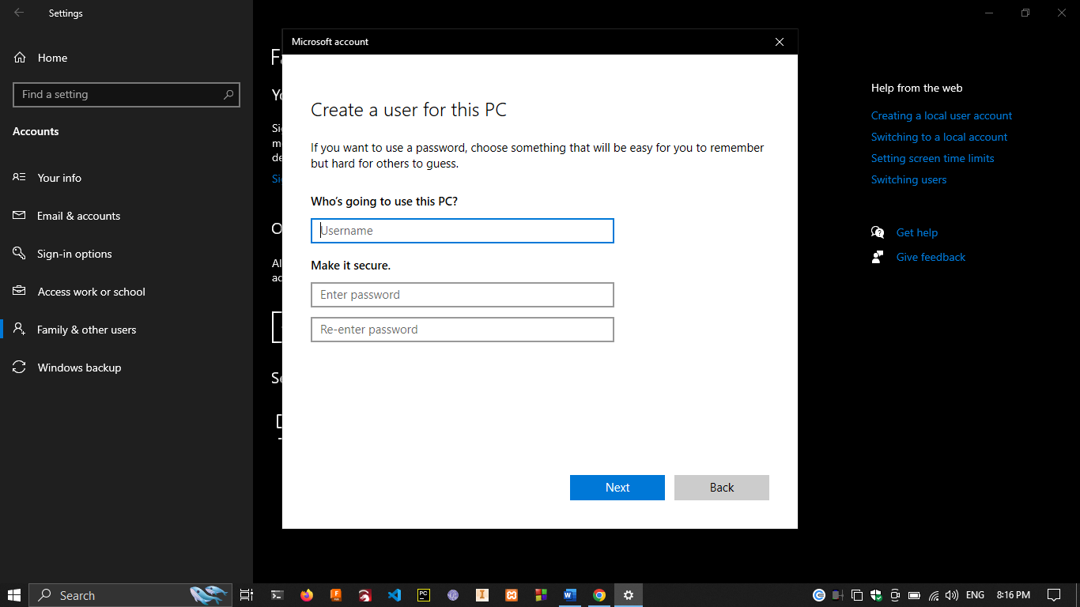

* 1. Change Account Name

Start -> Control panel -> User Account -> Changing the account name

* 1. Change the password

Control panel -> User Account -> Manage Other account -> change password -> enter the new password -> Click apply

* 1. Delete user

Settings -> Other users -> selecting the user account -> click Remove

1. Customizing file explorer
   * + 1. **Pin Folders to Quick access :-** Open file explorer -> right click on folder -> click “Pin to Quick Access”

**Unpin Folders in Quick access :-** Open file explorer -> right click on the already pinned folder -> click “Unpin from Quick Access”

* + - 1. File Explorer -> Select the Details view -> Click the View menu -> Click Add columns -> Select the columns you want to add -> Click OK
      2. Ctrl + F1 Or click on minimize the ribbon next to help button
      3. To display hidden folder and files. Open file explorer -> in the ribbon menu select view > check the Hidden items box
      4. Displaying different pans

1. Navigation Pane :- In file explorer -> under view -> click navigation pane to hide or show to Navigation pane
2. Next to navigation pane click on preview pane to show or hide navigation pane
3. Next to navigation pane click on Details pane to show or hide navigation pane
4. Most useful short cut Keys

|  |  |
| --- | --- |
| **Action** | **Shortcut** |
| Copy | Ctrl + C |
| Cut | Ctrl + X |
| Paste | Ctrl + V |
| Maximize Window | F11 or Windows logo key + up arrow |
| Minimize Window | Windows logo key + Down arrow Open |
| Task View | Windows logo key + Tab |
| Display and hide the desktop | Windows logo key + D |
| Open Search | Windows Key + S |
| Switch between open apps | Alt + Tab |
| Open the Quick Link menu | Windows logo Key + X |
| Lock your PC | Windows logo Key + L |